FICCI Trade Fair Secretariat  Federation House, Tansen Marg,  New Delhi – 110001  Tel: 91-11-32910417(D),  23738760-70  Fax: 91 11 23359734 (D)  E-Mail: indiaaviation@ficci.com | INDIA AVIATION 2008 | Last Date of Submission  August 31, 2008
 | INDIA AVIATION 2008 | Organiser’s Copy

FORM NO. 1

PROFORMA FOR COMPANY DATA FOR ENTRY IN THE OFFICIAL
EXHIBITORS’ DIRECTORY

1. Name of Organisation : ...................................................................................................
Stand No :............................................................ Hall No : ...........................................
Address :..........................................................................................................................
.........................................................................................................................................
City & Code : ..................................................... Country : ...........................................
Telephone :........................................................ Fax : ....................................................
E-mail : .............................................................. Website : ............................................
Name of the Chief Executive Officer :............................................................................
Designation :....................................................................................................................
Contact person for “India Aviation 2008” with designation :.......................................

2. Complete list of & range of products/services : ...............................................................
..............................................................................................................................................
..............................................................................................................................................
..............................................................................................................................................
..............................................................................................................................................
..............................................................................................................................................
..............................................................................................................................................
..............................................................................................................................................
(The number of words should not exceed 150. Organiser has right to edit the matter if it exceeds
150 words.) Group company or principal or foreign collaborator’s name and details of the participating company is possible as an additional entry. For additional entry you are required to fill the same form with the details of your group company or principal or foreign collaborator. A photocopy of this form can be used for sending the additional entry.

Company Name: ...................................................................................................................
Stall No. : ........................................................................Hall No.: ......................................
Contact Person : ....................................................................................................................
Signature : ........................................................................ Date: ..........................................

FICCI Trade Fair Secretariat  Federation House, Tansen Marg,  New Delhi – 110001  Tel: 91-11-32910417(D),  23738760-70  Fax: 91 11 23359734 (D)  E-Mail: indiaaviation@ficci.com | INDIA AVIATION 2008 | Last Date of Submission  August 31, 2008
 | INDIA AVIATION 2008 | Organiser’s Copy

Form No. 2
EXHIBITOR PHOTO PASSES

Notes:
- Exhibitor Photo Passes for the company personnel who will be manning your stand will be provided free of cost @ 2 passes for 12 sqm of area occupied but maximum number of free passes is restricted to 40. Details of personnel for Exhibitor Photo Passes may be furnished on the reverse of this form. Please send two coloured photographs of each person and also mention the name on the reverse of each photograph.

- Exhibitor Photo Passes beyond the authorised limit would be issued on payment of US $ 60 per pass for foreign exhibitors and Rs. 2000/- per pass for Indian exhibitors.

- Exhibitor should specify on the reverse of this form the name of the person, nationality, Passport details (compulsory for International Exhibitor), place of stay and most importantly the category for which the pass is required. Thus if a company requires their personnel in the chalet or stall or outdoor area they would have to specify the same. As each category of pass will allow the access in the area for which the pass has been requested for.

Payments to be made in favour of Account No.-31259 (Account Name : FICCI Exhibition); Bank Name & Address-United Bank of India, Overseas Branch, 3/16, Asaf Ali Road, New Delhi, India; Swift Code- SWIFT-BIC UTBIINBBDEL, Through American Express Bank, New York, A/c. No. 257139, SWIFT-AEIBUS33

Company Name: ...................................................................................................................
Stall No. : ........................................................................Hall No.: ......................................
Contact Person : ....................................................................................................................
Signature : ........................................................................ Date: ..........................................
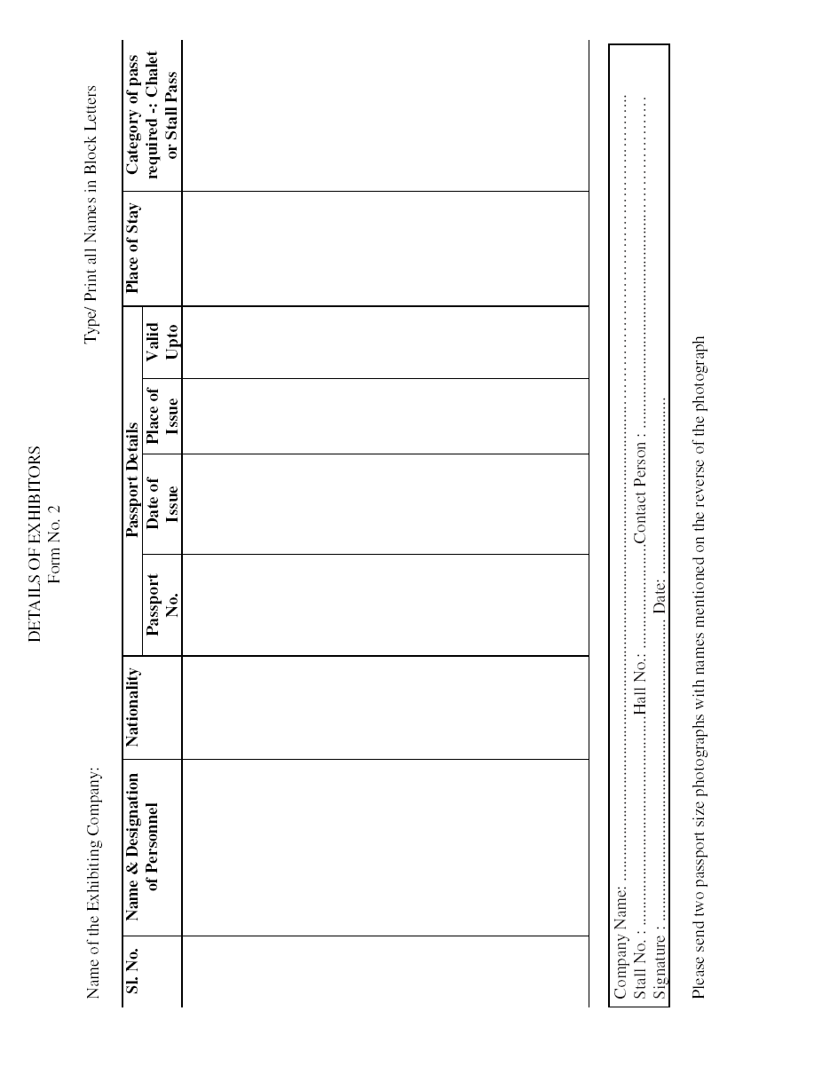

FICCI Trade Fair Secretariat  Federation House, Tansen Marg,  New Delhi – 110001  Tel: 91-11-32910417(D),  23738760-70  Fax: 91 11 23359734 (D)  E-Mail: indiaaviation@ficci.com | INDIA AVIATION 2008 | Last Date of Submission  August 31, 2008
 | INDIA AVIATION 2008 | Organiser’s Copy

FORM NO. 3
STAND FASCIA BOARD
(For Shell Scheme Stand Exhibitors Only)

(Please Type in Capital Letters)

Exhibiting Company’s Title:

Note: ... The above will appear in characters 12 cm high over open aisle frontage of all Shell Scheme Stands

Please note the following guidelines:
If no confirmation is received by 31 August 2008, the name available on application form or letterhead will be used.
Raw space holders shall not be supplied with any fascia name.
Last minute changes shall not be entertained.
Fascia name to be restricted to a maximum of 30 letters including spaces. Delete “Pvt. Ltd.”, etc.

Company Name: ...................................................................................................................
Stall No. : ........................................................................Hall No.: ......................................
Contact Person : ....................................................................................................................
Signature : ........................................................................ Date: ..........................................

FICCI Trade Fair Secretariat  Federation House, Tansen Marg,  New Delhi – 110001  Tel: 91-11-32910417(D),  23738760-70  Fax: 91 11 23359734 (D)  E-Mail: indiaaviation@ficci.com | INDIA AVIATION 2008 | Last Date of Submission  October 18, 2008
 | INDIA AVIATION 2008 | Organiser’s Copy

FORM No. 4
FORMAT FOR EXIT PASS

EXHIBITORS SHOULD REPRODUCE EXIT PASS IN THE BELOW MENTIONED FORMAT ON THEIR LETTERHEAD AND FOUR COPIES MUST BE PREPARED IN ORDER TO TAKE THEIR GOODS OUT OF THE EXHIBITION VENUE ON THE CONCLUDING DAY OF THE EXHIBITION.

To
Federation of Indian Chambers of Commerce and Industry
Tansen Marg, New Delhi

Dear Sir,

We have paid all our dues to Federation of Indian Chambers of Commerce and Industry and there is no balance whatsoever. However our security lying with you may be released after adjusting any further dues that may be payable from our side.

Therefore, please allow us to take out the following goods, which we had brought for display during the exhibition.

Sr. No. | Description of Items | No. of Packing cases

Company Name: ...................................................................................................................
Stall No. : ........................................................................Hall No.: ......................................
Contact Person : ....................................................................................................................
Signature : ........................................................................ Date: ..........................................

Note :

1. Please obtain ‘No objection from Federation of Indian Chambers of Commerce & Industry. Trade Fairs Department.
2. Please use letterheads of your company OR attach business card & take 4 copies while preparing this format that will enable you to avail of an exit pass.
3. Early submission will help to facilitate a smooth exit from Exhibition Venue.

FICCI Trade Fair Secretariat  Federation House, Tansen Marg,  New Delhi – 110001  Tel: 91-11-32910417(D),  23738760-70  Fax: 91 11 23359734 (D)  E-Mail: indiaaviation@ficci.com | INDIA AVIATION 2008 | Last Date of Submission  August 31, 2008
 | INDIA AVIATION 2008 | Organiser’s Copy

FORM NO. 5
APPLICATION FOR APPROVAL OF RAW SPACE DESIGN
(Plus Drawings)

Important
1. Drawings submitted for approval must show the plan view, front & side elevations with fittings, raised platforms, ramps, stairs etc. An electrical wiring diagram is also to be submitted.
2. The Organisers shall supply carpet to aisles, public areas and shell stands only. Raw space stands will not be supplied with carpet.
• In accordance with Exhibition Regulations, kindly attach for approval two copies of dimensional drawings/views showing structures & fittings to be built into your stand display.
• Also enclose a 3-phase power location plan to enable the Official Electrical Supplier to ensure power outlets to be located appropriately.
• Submission beyond the 31st August 2008 will invite fees of Rs. 10,000/US$ 250

3. For electricity, please apply through Form No. 6

Name of the contractor for stand design and construction is:

Contractor’s name: ...............................................................................................................
Address & Contact Person: ...................................................................................................
Telephone: .............................. Fax: ................................ e-mail: ........................................
Signed for Exhibitor by: ........................................................................................................
Name of Signatory: ...............................................................................................................
Appointment/Designation: ....................................................................................................
Company’s Stamp: ................................................................................................................

Company Name: ...................................................................................................................
Stall No. : ........................................................................Hall No.: ......................................
Contact Person : ....................................................................................................................
Signature : ........................................................................ Date: ..........................................

FICCI Trade Fair Secretariat  Federation House, Tansen Marg,  New Delhi – 110001  Tel: 91-11-32910417(D),  23738760-70  Fax: 91 11 23359734 (D)  E-Mail: indiaaviation@ficci.com | INDIA AVIATION 2008 | Last Date of Submission  August 31, 2008
 | INDIA AVIATION 2008 | Organiser’s Copy

FORM NO. 6
ELECTRICAL CONNECTION

THIS FORM MUST BE COMPLETED AND RETURNED BY EVERY EXHIBITOR. IF THIS SERVICE IS NOT REQUIRED, PLEASE ENDORSE “NOT APPLICABLE” AND RETURN THIS FORM TO THE ADDRESS MENTIONED ABOVE.

Permanent Power

S. No. | Particulars | Duration | Charges Per Kw in Rs/US$ | Qty in Kws | Amount | Service Tax 12.36% | Grand Total
1. | For Bare Space | October 14-18, 2008 | INR 3000 / US$ 100
2 | For Outdoor Space | October 14-18, 2008 | INR 3000 / US$ 100
3 | For Chalet | October 14-18, 2008 | INR 3000 / US$ 100
4. | Additional Power (For Shell Scheme stands) | October 14-18, 2008 | INR 1000 / US$ 30

Temporary Power (Set Up and Dismantling Days). Kindly mentioned the dates from _____________________ till _______________ temporary power is required

S. No. | Particulars | Duration | Charges Per Kw in Rs/US$ | Qty in Kws | Total No of days on which temporary power is required | Amount | Service Tax 12.36% | Grand Total
1 | Indoor Stall | Per day Basis | INR 1000 / 30
2 | Outdoor Stall | Per day Basis | INR 1000 / 30
3 | Chalet | Per day Basis | INR 1000 / 30

*Service Tax of 12.36% will be charged extra for all the Indian Exhibitors

To avail electrical connections the above mentioned amounts are mandatory. The charges include connection & consumption of electricity for the duration mentioned.
(i) Shell scheme stands are provided with a total power load of 1 kw per 12 Sqm.., including the load for spot lights, free of charge, in the stand package. For additional power the exhibitors in shell stand needs to fill this forms and apply.
(ii) Raw space stands and outdoor spaces will not be provided with any electricity connection unless they apply specially through this Form.

Payments to be made in favour of Account No.-31259 (Account Name : FICCI Exhibition); Bank Name & Address-United Bank of India, Overseas Branch, 3/16, Asaf Ali Road, New Delhi, India; Swift Code- SWIFT-BIC UTBIINBBDEL, Through American Express Bank, New York, A/c. No. 257139, SWIFT-AEIBUS33

Company Name: ...................................................................................................................
Stall No. : ........................................................................Hall No.: ......................................
Outdoor Stall No. : .........................................................Chalet No.: ..................................
Contact Person : ....................................................................................................................
Signature : ........................................................................ Date: ..........................................

FICCI Trade Fair Secretariat  Federation House, Tansen Marg,  New Delhi – 110001  Tel: 91-11-32910417(D),  23738760-70  Fax: 91 11 23359734 (D)  E-Mail: indiaaviation@ficci.com | INDIA AVIATION 2008 | Last Date of Submission  August 31, 2008
 | INDIA AVIATION 2008 | Organiser’s Copy
FORM NO. 7
EXHIBITION CATALOGUE - “India Aviation 2008”
ADVERTISMENT TARRIF (PRINTED CATALOGUE)

Option No. | Position | Rs. | US$ | Mark the option
 | Double spread (Colour) | 2,50,000.00 | 6500.00
 | Back Cover (Colour) | 2,00,000.00 | 5000.00
 | Inside Front Cover (Colour) | 1,50,000.00 | 4500.00
 | Opening First Page (Colour) | 1,50,000.00 | 4500.00
 | Inside Back Cover (Colour) | 1,25,000.00 | 3500.00
 | Full Page (Colour) | 1,00,000.00 | 3500.00
 | Book Mark (2 Side) | 1,00,000.00 | 3500.00
 | Half Page (Colour) | 75,000.00 | 2500.00

Encircle the amount applicable for opted advertisement.

*Service Tax of 12.36% will be charged extra for all the Indian Exhibitors

Technical Data

Full Page  - Print Area  12 x 19 cms.  (Width x Height) |  | Half Page  (Horizontal)  - Print Area  12 x 9.5 cms. (Width x Height) |  | Book Mark  - Print Area  12 x 9.5 cms. (Width x Height) |  | Double Spread  - Print Area  24 x 9.5 cms. (Width x Height)

ADVERTISEMENT TARIFF (CD CATALOGUE)

Category Tariff
Rs. US$
Animated Presentation. 50,000.00 2000.00
(1 Min) Presentation to be Provided by Advertiser
Gold Sponsor On request
Silver Sponsor On request

Note:

Advertisement material required:
• CDR, TIFF, EPS file in high resolution in CD with printed colour copy of the Advertisement as a reference proof.
• Positive or Artwork.
• Book Mark should be provided by the advertiser.
• For CD, the material should be sent in visual format in CD

Please reserve_____________ in printed Catalogue/CD Catalogue :

Payment details:

Payments to be made in favour of “FICCI” to United Bank of India, SWIFT UTBIINBBDEL, A/c No. CA.11683 at TANSEN MARG Branch through United Bank of India, OVERSEAS branch, American Express Bank, New York, A/c No. 257139 (SWIFT AE1BUS33)

Company Name: ...................................................................................................................
Stall No. : ........................................................................Hall No.: ......................................
Contact Person : ....................................................................................................................
Signature : ........................................................................ Date: ..........................................

FICCI Trade Fair Secretariat  Federation House, Tansen Marg,  New Delhi – 110001  Tel: 91-11-32910417(D),  23738760-70  Fax: 91 11 23359734 (D)  E-Mail: indiaaviation@ficci.com | INDIA AVIATION 2008 | Last Date of Submission  August 31, 2008
 | INDIA AVIATION 2008 | Organiser’s Copy

FORM NO. 8
CONTRACTOR PHOTO PASSES

Notes:
• For designing and construction of customised stall we advise that the exhibitors should take the services of any of the official customised stand construction agencies mention on Page No. 27. These agencies are reputed in their area of working and can deliver upto to the satisfaction of exhibitors.
• Details of personnel who will be constructing/decorating stands/chalets other than official customise stand contractors may be furnished on the reverse of this form by the exhibitor along with a letter of authority nominating the contracting company for such services. Please send two coloured photographs of each person and also mention the name on the reverse of each photograph.
• The exhibitor must also declare in the nomination letter that he accepts the responsibility and guarantees for the payment of any dues/fines as a result of acts of commission or omission of his contracting company.
• In case an exhibitor is not in a position to provide details of personnel likely to be deputed by his contractor, he must specifically say so in a letter to the Organisers and request his contractor to provide the necessary details to the Organisers by the due date.
• Each pass will cost Rs 500/US$ 15 per pass. Incase an exhibitor is engaging services of official customised stand contractor the passes will be provided free of charge.
• Exhibitor should specify on the reverse of this form the name of the person, nationality, Passport details (compulsory for International Exhibitor), place of stay and most importantly the category for which the pass is required. Thus if a company requires the contractor pass for the contractor to work in the chalet or stall or outdoor area they would have to specify the same. As each category of pass will allow the access to the area for which the pass has been requested for.

Payments to be made in favour of Account No.-31259 (Account Name : FICCI Exhibition); Bank Name & Address-United Bank of India, Overseas Branch, 3/16, Asaf Ali Road, New Delhi, India; Swift Code- SWIFT-BIC UTBIINBBDEL, Through American Express Bank, New York, A/c. No. 257139, SWIFT-AEIBUS33

Company Name: ...................................................................................................................
Stall No. : ........................................................................Hall No.: ......................................
Contact Person : ....................................................................................................................
Signature : ........................................................................ Date: ..........................................

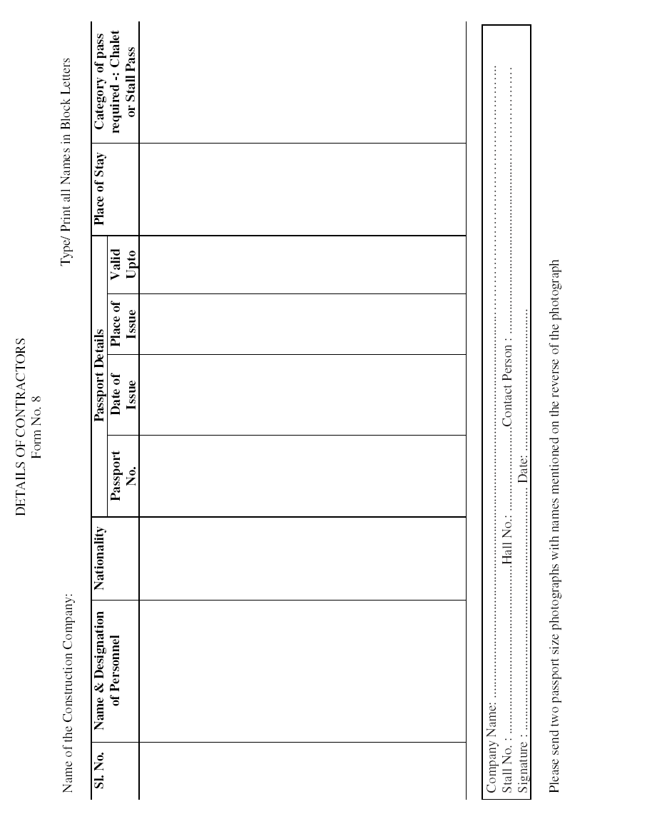

FICCI Trade Fair Secretariat  Federation House, Tansen Marg,  New Delhi – 110001  Tel: 91-11-32910417(D),  23738760-70  Fax: 91 11 23359734 (D)  E-Mail: indiaaviation@ficci.com | INDIA AVIATION 2008 | Last Date of Submission  August 31, 2008
 | INDIA AVIATION 2008 | Organiser’s Copy

FORM NO. 9
SERVICE PROVIDER PHOTO PASSES
Notes:
1. Service provider photo passes will be issued to such personnel including hostesses/drivers of the exhibitor/contracting agency whose services are essentially required at stall/chalet by the exhibiting company during the show period. These will be issued at the rate of 4 for space up to 100 sqm and a maximum of 10. Details of personnel may be furnished on the reverse of this form.

2. Two badges for each chalet booked will be given in addition.

- Additional Passes will be available for US $ 60 / Rs 2000 per pass.

- Exhibitor should specify on the reverse of this form the name of the person, nationality, Passport details (compulsory for International Exhibitor), place of stay and most importantly the category for which the pass is required. Thus if a company requires the services of the host/ hostess/ Security Guard/ Driver etc in the chalet or stall or outdoor area they would have to specify the same. As each category of pass will allow the access to the area for which the pass has been requested for.

Payments to be made in favour of Account No.-31259 (Account Name : FICCI Exhibition); Bank Name & Address-United Bank of India, Overseas Branch, 3/16, Asaf Ali Road, New Delhi, India; Swift Code- SWIFT-BIC UTBIINBBDEL, Through American Express Bank, New York, A/c. No. 257139, SWIFT-AEIBUS33

Company Name: ...................................................................................................................
Stall No. : ........................................................................Hall No.: ......................................
Contact Person : ....................................................................................................................
Signature : ........................................................................ Date: ..........................................
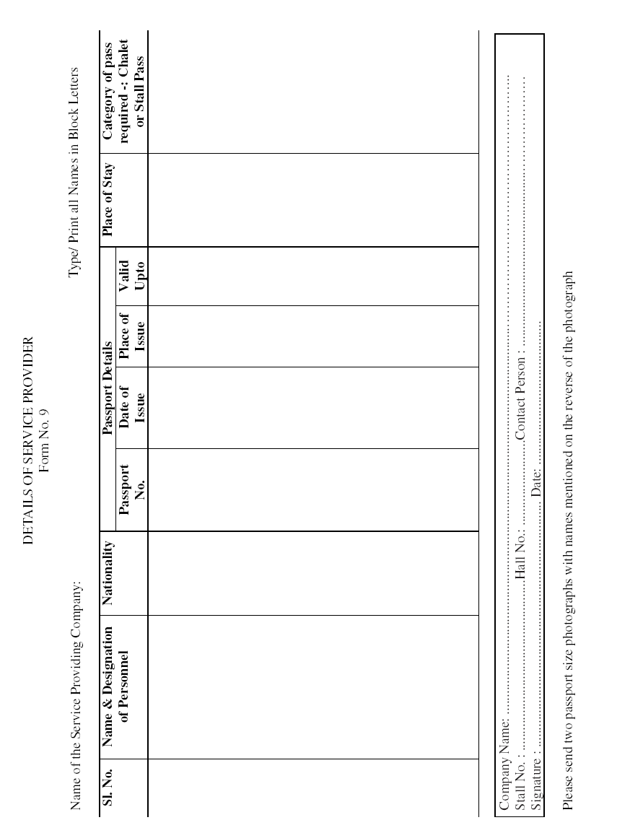

FICCI Trade Fair Secretariat  Federation House, Tansen Marg,  New Delhi – 110001  Tel: 91-11-32910417(D),  23738760-70  Fax: 91 11 23359734 (D)  E-Mail: indiaaviation@ficci.com | INDIA AVIATION 2008 | Last Date of Submission  August 31, 2008
 | INDIA AVIATION 2008 | Organiser’s Copy

FORM NO. 10
PRESS CONFERENCE

Kindly inform the Organisers if you will be holding a press conference/giving a presentation.

Please list your preferences in order below:
(i) .........................................(ii)..............................................(iii)........................................

An amount of US $............................................................................... is being transferred.

Payment can be made once the slot is confirmed by the Organiser

Note: Availability of time slots may be checked from the website www.india-aviation.in

Charges : | 60 Seater | US $ 400 / Rs. 15,000 per 45 min

Payment to be made against invoice which shall be issued separately.

Time Slot - Hall 1 (60 Seater)
(each slot is of 30 minutes with 15 minutes preparation time) kindly _mark the slot of your preference
15.10.2008 |  | 16.10.2008 |  | 17.10.2008 |  | 18.10.2008
 |  | 10:00 am – 10:45 am |  | 10:00 am – 10:45 am |  | 10:00 am – 10:45 am
 |  | 10:50 am – 11:35 am |  | 10:50 am – 11:35 am |  | 10:50 am – 11:35 am
 |  | 11:40 am – 12:25 am |  | 11:40 am – 12:25 am |  | 11:40 am – 12:25 am
 |  | 12:30 am – 01:15 am |  | 12:30 am – 01:15 am |  | 12:30 am – 01:15 am
 |  | Lunch Break |  | Lunch Break |  | Lunch Break
2:00 pm – 2:45 pm |  | 02:00 am – 02:45 am |  | 02:00 am – 02:45 am |  | 02:00 am – 02:45 am
2:50 pm – 3:35 pm |  | 02:50 am – 03:35 am |  | 02:50 am – 03:35 am |  | 02:50 am – 03:35 am
3:40 pm – 4:25 pm |  | 03:40 am – 04:25 am |  | 03:40 am – 04:25 am |  | 03:40 am – 04:25 am

Company Name: ...................................................................................................................
Stall No. : ........................................................................Hall No.: ......................................
Contact Person : ....................................................................................................................
Signature : ........................................................................ Date: ..........................................

FICCI Trade Fair Secretariat  Federation House, Tansen Marg,  New Delhi – 110001  Tel: 91-11-32910417(D),  23738760-70  Fax: 91 11 23359734 (D)  E-Mail: indiaaviation@ficci.com | INDIA AVIATION 2008 | Last Date of Submission  August 31, 2008
 | INDIA AVIATION 2008 | Organiser’s Copy

FORM NO. 11
TELEPHONE & FAX ON HIRE

TELEPHONE FACILITY

We hereby order the Telephone for our Stall No. _______ No. of Telephone Machines Required / Chalet No. ________ No. of Telephone Machines Required / Outdoor Stall Number__________ No. of Telephone Machines Required. (please tick where ever the facility is required and also mention your stall number or chalet number)

Facility | Qty. | Charges (Rs. / US $) | Amount Payable in (Rs. / US $)
Telephone (without STD/ISD) |  | 6,500/200
Telephone (with STD/ISD) |  | 11,500/300
Grand Total

FAX FACILITY

We hereby order the Fax Machine for our Stall No. _______ No. of Fax Machines Required _______ Chalet No. ________ No. of Fax Machines Required /Outdoor Stall Number__________ No. of Fax Machines Required. (please tick where ever the facility is required and also mention your stall number or chalet number)

Facility | Qty. | Charges (Rs. / US $) | Amount Payable in (Rs. / US $)
Fax Machine (without the line, only the equipment.) |  | 6,500/200
Telephone line (without STD/ISD) |  | 6,500/200
Telephone line (with STD/ISD) |  | 11,500/300
Grand Total

*Service Tax of 12.36% will be charged extra for all the Indian Exhibitors

Exhibitor would have to apply for telephone line for the Fax Machine according to the range required by them. Exhibitors requiring to send fax only with in Hyderabad than they would have to apply for telephone line without STD /ISD. Exhibitors requiring to send the fax outside Hyderabad & India would have to opt for telephone line with (STD & ISD)

Note:
- Actual usage charges will be levied from the exhibitors against invoice raised by the dealing agency or the exhibitors would be required to purchase calling cards. The details of the different values of calling cards would be given closer to the event.

- PCO with Local with in Hyderabad /STD/ISD, Xerox, Fax, e-mail facilities would be available in business centers and charges will be on actuals.

Payments to be made in favour of Account No.-31259 (Account Name : FICCI Exhibition); Bank Name & Address-United Bank of India, Overseas Branch, 3/16, Asaf Ali Road, New Delhi, India; Swift Code- SWIFT-BIC UTBIINBBDEL, Through American Express Bank, New York, A/c. No. 257139, SWIFT-AEIBUS33

Company Name: ...................................................................................................................
Stall No. : ........................................................................Hall No.: ......................................
Contact Person : ....................................................................................................................
Signature : ........................................................................ Date: ..........................................

FICCI Trade Fair Secretariat  Federation House, Tansen Marg,  New Delhi – 110001  Tel: 91-11-32910417(D),  23738760-70  Fax: 91 11 23359734 (D)  E-Mail: indiaaviation@ficci.com | INDIA AVIATION 2008 | Last Date of Submission  August 31, 2008
 | INDIA AVIATION 2008 | Organiser’s Copy

FORM NO. 12
SPECIFICATIONS OF HEAVY AND LARGE EXHIBITS
HEAVY/LARGE EXHIBITS

Heavy/Large Exhibits
Exhibit Name | Weight (KGS) | Length (Mtrs.) | Width (Mtrs.) | Height (Mtrs.) | Load Distribution Point (No. & Demensions)

Note:
- Exhibitors must give correct details of heavy and large exhibits that they are going to display at their stall. This will help us in creating a proper infrastructure and facilitate the movement and placement of these exhibits into the halls. Photographs of large and heavy exhibts should also be sent.

- It is mandatory for exhibitor to bring weight bridge certificate (Dharamkanta) reflecting the weight of exhibits. Incase the exhibitor fail to produce the weight bridge certificate in such case the weight assessed by R E Rogers India Pvt Ltd will be deemed as weight of the exhibits.

Company Name: ...................................................................................................................
Stall No. : ........................................................................Hall No.: ......................................
Contact Person : ....................................................................................................................
Signature : ........................................................................ Date: ..........................................

Aman Mahajan  Manager – MICE India  Orbitz Corporate & Leisure Travels (I) Pvt. Ltd.  103, Navyug Industrial Estate,  T J Road, Sewree West, Mumbai – 15, India.  Direct Telephone: 91 (22) 2419 7438 / 9322037954  Direct Fax mail: 91 (22) 2418 4659  Board Line: 91 (22) 2410 2801/02/03  E-Mail: aman@orbitz-world.com | Mayur Sud  Travel Consultant MICE India  Orbitz Corporate & Leisure Travels (I) Pvt. Ltd.  4/10 EAST PATEL NAGAR  NEW DELHI - 110008. India.  Direct Telephone: 91 (0) 9312911611  Board Line: 91 (11) 45051302 - 09  E-Mail: miceindia.del@orbitz-world.com | Last Date of Submission  August 31, 2008
 |  | Organiser’s Copy

INDIA AVIATION 2008

FORM NO. 13
TRAVEL & ACCOMODATION
S.No. | Particulars | Please Tick Mark
 | Hotels in Hyderabad
 | Airport Transfer
 | Local Transport
 | Sight Seeing

Please send us the detail information on the above:

Mode of Payment:

- Cheque/DD for USD/Rs._____________in favour of Orbitz Corporate & Leisure Travels (I) Pvt. Ltd.. Dated.___________ Chq No.________________

- Swift Transfer: USD Remittance - DETAILS FOR TRANSFER OF FUND,

Correspondent Bank | Deutche Bank Trust Company,  Americas, 60, Wall Street, New York, NY 10005
Swift Code | BKTRUS33
Fed Wire Routing | 021001033
Deutsche Bank‘S Account No | 04-411-536
Name Of Beneficiary | Orbitz Corporate & Leisure Travels ( I ) Pvt Ltd
Bank Of Beneficiary | Deutsche Bank Ag, Mumbai Branch, India
Beneficiary ‘S Bank A/C No | 055-7991-05-1
Swift Code | DEUTINBBXXX

3. Credit Card:  VISA  MASTER  AMERICAN EXPRESS
Card No.________________________ Expiry Date: ____________ Rs. ________ USD ____________
Please fax the front & reverse of the credit card along with the form.

For Booking & Terms & Conditions
Please Contact: Mr. Aman Mahajan / Mr Chayan Bulani
103, Navyug Industrial Estate,T.J. Road, Sewri (W), Mumbai – 400 015,
Tel: 91 (22) 24197438/463 Fax: 91(22) 24184659/24102805 Mobile: 93220 37954 / 93222 08530
E-mail: aman@orbitz-world.com / miceindia.ops@orbitz-world.com

Company Name: ...................................................................................................................
Stall No. : ........................................................................Hall No.: ......................................
Contact Person : ....................................................................................................................
Signature : ........................................................................ Date: ..........................................

FICCI Trade Fair Secretariat  Federation House, Tansen Marg,  New Delhi – 110001  Tel: 91-11-32910417(D),  23738760-70  Fax: 91 11 23359734 (D)  E-Mail: indiaaviation@ficci.com | INDIA AVIATION 2008 | Last Date of Submission  August 31, 2008
 | INDIA AVIATION 2008 | Organiser’s Copy

FORM NO. 14
PROPOSAL FORM FOR PUBLIC LIABILITY INSURANCE
(For Non-industrial Risk)

Liability of the company does not commence until the proposal has been accepted and the premium paid. The TERRITORIAL LIMIT AS APPLICABLE TO THIS POLICY IS ANY WHERE IN INDIA.

All questions should be with respect to each unit/establishment.
1. Name of the Proposer (in full) : ____________________________________________
2. Address of the Proposer : _________________________________________________
3. Description of the premises
(a) Shell Scheme / Raw Space and area booked : __________________________
(b) Type of Construction: _____________________________________________
(c) Activities being carried on in the premises: ____________________________
4. Are the premises/equipment/machinery : ____________________________________
In sound condition _____________________________________________________
5. Have you complied with all statutory rules/regulations pertaining to the premises and your business activities: YES / NO
6. Please indicate the limits of indemnity required:
(a) Any one accident: ______________________________________________________
(b) Any one period : _______________________________________________________
7. Policy Period Required: From _____________________________________________ To _______________________________________________

I/we desire to effect an insurance in terms of the public liability of the policy of the Company against the limits of indemnity specified above. I/we thereby declare that all statutory provisions pertaining to my/our business proposed for insurance and complied with. I/we further declare that the above statement and particulars are true and I/we have not omitted, suppressed, misrepresented or misstated any material fact and I/we agree that this declaration shall be the basis of contract between me/us and the Company and be incorporated therein.

Company Name: ...................................................................................................................
Stall No. : ........................................................................Hall No.: ......................................
Contact Person : ....................................................................................................................
Signature : ........................................................................ Date: ..........................................
FICCI Trade Fair Secretariat  Federation House, Tansen Marg,  New Delhi – 110001  Tel: 91-11-32910417(D),  23738760-70  Fax: 91 11 23359734 (D)  E-Mail: indiaaviation@ficci.com | INDIA AVIATION 2008 | Last Date of Submission  August 31, 2008
 | INDIA AVIATION 2008 | Organiser’s Copy

FORM NO. 15
HIRING ADDITIONAL ITEMS
ADDITIONAL EQUIPMENT (Rentals for Duration of Exhibiton)

The following items will be supplied at prices indicated against each:-

S No. | Item Code | Description | Size / Specification | Unit Cost in INR | Unit Cost in US $ | Unit Cost in EURO | Qty. Reqd. | Total
1 | PI-01 | Executive Chair | Grey Color | 1,150.00 | 27.00 | 22.00
2 | PI-02 | Computer Chair | Blue Color | 925.00 | 22.00 | 18.00
3 | PI-03 | Sofa Seater (Single) | Red Color | 925.00 | 22.00 | 18.00
4 | PI-04 | Sofa Chair with arm |  | 2,875.00 | 67.00 | 53.00
5 | PI-04A | Sofa chair armless |  | 1,725.00 | 41.00 | 33.00
6 | PI-05 | Visitor Chair  (with arm rest) |  | 700.00 | 17.00 | 13.00
7 | PI-06 | Visitor chair |  | 475.00 | 12.00 | 10.00
8 | PI-07 | VIP Sofa (1 SEATER) | Black Leather | 1,440.00 | 34.00 | 27.00
9 | PI-07A | VIP Sofa (2 SEATER) | Black Leather | 2,875.00 | 67.00 | 53.00
10 | PI-07B | VIP Sofa (3 SEATER) | Black Leather | 3,750.00 | 88.00 | 69.00
11 | PI-08 | Conference Chair |  | 700.00 | 17.00 | 13.00
12 | PI-09 | Wooden Chair / High Stool | Wooden Color | 700.00 | 17.00 | 13.00
13 | PI-10 | Folding chair Black Color |  | 175.00 | 5.00 | 4.00
14 | PI-11 | Bar Stool (High) with/ without back rest |  | 575.00 | 14.00 | 11.00
15 | PI-12 | Bar Stool (Low) |  | 525.00 | 13.00 | 10.00
16 | PI-12A | Bar Stool (Adjustable Chrome leg with Cup) |  | 825.00 | 20.00 | 15.00
17 | PI-13 | Round Table (Wooden top) |  | 825.00 | 21.00 | 17.00
18 | PI-14 | Round Table Glass Top with wooden/Chrome leg |  | 1,050.00 | 25.00 | 20.00
19 | PI-15 | Round Table(White laminated top) |  | 825.00 | 20.00 | 15.00
20 | PI15A | Television Counter | 1.2M ht, 0.5m, x 0.5 | 1,150.00 | 27.00 | 22.00
21 | PI-16 | Glass Counter | 1M X 0.50M, X 1M | 2,075.00 | 49.00 | 38.00
22 | PI-17 | System Counter (Table) | 1.05M X 0.60M, X 0.75M | 875.00 | 21.00 | 17.00
Any other item : On special request and subject to availability.

23 | PI-18 | Two level Information Counter | 1mx.6mx1.1 mx.75 m | 1,725.00 | 41.00 | 33.00
24 | PI-19 | Side Rack | 0.40 CMX1M.X0.60 CM | 2,075.00 | 49.00 | 38.00
25 | PI-20 | Glass Showcase Small | 0.5M X 0.5M X 2M H | 2,875.00 | 67.00 | 53.00
26 | PI-21 | Glass Showcase Big with 2 downlights | 1Mx0.5Mx2MT HT. | 3,450.00 | 81.00 | 65.00
27 | PI-22 | Centre Table | 1.2M X 0.45M | 575.00 | 14.00 | 11.00
28 | PI-23 | Corner Table | 0.45M X 0.45M | 475.00 | 12.00 | 10.00
29 | PI-24 | Square Table | 0.70M X 0.70M x 0.70M | 575.00 | 14.00 | 11.00
30 | PI-24A | Office Table | 1.2mx1mx0.7m | 1,725.00 | 41.00 | 33.00
31 | PI-24B | Standing Discussion | Table 1.0M Ht x0.7M dia | 875.00 | 21.00 | 17.00
32 | PI-27 | Brouchure Rack |  | 475.00 | 12.00 | 10.00
33 | PI-28 | Garment Stand |  | 575.00 | 14.00 | 11.00
34 | PI-29 | Garment stand adjustable |  | 700.00 | 17.00 | 13.00
35 | PI-30 | Glass Shelf Set of 3 Nos |  | 1,050.00 | 25.00 | 20.00
36 | PI-30A | Wooden Shelf Flat/Adjustable |  | 425.00 | 10.00 | 8.00
37 | PI-31 | Pin-up Board with Fabric covering | 1M L X0.95M H | 925.00 | 22.00 | 18.00
38 | PI-32 | Wire Mesh | 2m L x 0.9m w | 700.00 | 17.00 | 13.00
39 | PI-33 | Chain Barricading (1M rope with two legs) | PER METER | 575.00 | 14.00 | 11.00

Payment Instruction: Please mark the items and mentioned quantity against each item and send the form directly to Pavilions and Interiors (I) Pvt. Ltd. with payment through demand draft in favour of Pavilions and Interiors (I) Pvt. Ltd. as per the following details:

Bank Details
Name of Company : Pavilions and Interiors (I) Pvt. Ltd.
Account No : 208000
Swift Code : ABNAINBBDEL
Bank Name : ABN AMRO BANK
Address : Hansalaya, 15 Barakamba Road, New Delhi – 01

NOTE
- All rates are for the duration of the show unless otherwise mentioned. Please make the order with the items code & name.
- The item are subject to availability.
- Any damage to the items by exhibitors will be liable for penalty.
- Any dispute regarding supply or any other issue related to the additional item will have to be settled by exhibitor directly with the agency Pavilions and Interiors (I) Pvt. Ltd.

Company Name: ...................................................................................................................
Stall No. : ........................................................................Hall No.: ......................................
Contact Person : ....................................................................................................................
Signature : ........................................................................ Date: ..........................................

FICCI Trade Fair Secretariat  Federation House, Tansen Marg,  New Delhi – 110001  Tel: 91-11-32910417(D),  23738760-70  Fax: 91 11 23359734 (D)  E-Mail: indiaaviation@ficci.com | INDIA AVIATION 2008 | Last Date of Submission  August 31, 2008
 | INDIA AVIATION 2008 | Organiser’s Copy

FORM NO. 15B
HIRING ADDITIONAL ITEMS
ADDITIONAL EQUIPMENT (Rentals for Duration of Exhibiton)

The following items will be supplied at prices indicated against each:-
ELECTRICAL EQUIPMENTS
S.No. |  | Item Code | Description | Size / Specification | Unit Cost in INR | Unit Cost in US $ | Unit Cost in EURO | Qty Reqd. | Total
Electrical Equipments / Power Load
1 | PI-40 |  | Halogen Lamp |  | 575.00 | 14.00 | 11.00
2 | PI-41 |  | Metal Halide |  | 1,150.00 | 27.00 | 22.00
3 | PI-42 |  | Ceiling down light |  | 425.00 | 10.00 | 8.00
4 | PI-43 |  | Spot Light |  | 350.00 | 8.00 | 7.00
5 | PI-43A |  | Long Arm halogen Light |  | 425.00 | 10.00 | 8.00
6 | PI-43B |  | Arm Light |  | 350.00 | 8.00 | 7.00
7 | PI-44 |  | Fridge - 165 Ltr |  | 2,300.00 | 54.00 | 43.00
8 | PI-44A |  | Fridge - 90 Ltr |  | 1,725.00 | 41.00 | 33.00
9 | PI-45 |  | 15/13 AMP Socket |  | 350.00 | 8.00 | 7.00
10 |  |  | Multi Pin adaptor |  | 125.00 | 3.00 | 3.00
11 |  |  | 50W / Low Voltage spot  Lights |  | 700.00 | 17.00 | 13.00
12 |  |  | 50W Long arm Spot light |  | 700.00 | 17.00 | 13.00
13 |  |  | 150W Halogen |  | 925.00 | 22.00 | 18.00
14 |  |  | 40W Fluorescent Tubes |  | 525.00 | 13.00 | 10.00
15 |  |  | Wall Lights |  | 525.00 | 13.00 | 10.00
16 |  |  | Track light with 3 nos 50W  downlights |  | 2,200.00 | 51.00 | 41.00
17 |  |  | - for three phase |  | 250.00 | 6.00 | 5.00
18 | PI-46 |  | Coffee machine  with consumable | PER DAY | 1,725.00 | 41.00 | 33.00
19 | PI-46A |  | Electric Kettle |  | 1,150.00 | 27.00 | 22.00
20 | PI-47 |  | Microwave Oven | PER DAY | 3,450.00 | 81.00 | 65.00
21 | PI-48 |  | Water Dispenser | PER DAY | 1,150.00 | 27.00 | 22.00

S.No. |  | Item Code | Description | Size / Specification |  | Unit Cost in INR | Unit Cost in US $ | Unit Cost in EURO | Qty Reqd. | Total
Miscellaneous Items
1 | PI-34 |  | Lockable Door |  |  | 2,875.00 | 67.00 | 53.00
2 | PI-34A |  | System folding door White |  |  | 1,725.00 | 41.00 | 33.00
3 | PI-34B |  | Venetian Blinds |  |  | 1,725.00 | 41.00 | 33.00
4 | PI-35 |  | System Panel White |  |  | 925.00 | 22.00 | 18.00
5 | PI-35A |  | Acrylic panel |  |  | 2,875.00 | 67.00 | 53.00
6 | PI-36 |  | Wall Coat Hanger |  |  | 300.00 | 7.00 | 6.00
7 | PI-36A |  | Self Standing Coat Hanger |  |  | 500.00 | 11.00 | 10.00
8 | PI-37 |  | (a) T-Bolt |  |  | 25.00 | 1.00 | 1.00
9 | PI-38 |  | (b) Graphic Retainer |  |  | 25.00 | 1.00 | 1.00
10 | PI-39 |  | (c) Photo Clip |  |  | 25.00 | 1.00 | 1.00
S.No. | Item Code |  | Description |  | Size / Specification | Unit Cost in INR | Unit Cost in US $ | Unit Cost in EURO | Qty Reqd. | Total
Water Connection / Compressed Air
1 | PI-59 |  | Sink unit with sink |  |  | 4,000.00 | 94.00 | 75.00
2 |  |  | 1HP 80 PSI 3/4" Outlet |  |  | 11,500.00 | 268.00 | 213.00
3 |  |  | 2 HP 100 PSI 3/4" Outlet |  |  | 17,250.00 | 402.00 | 320.00
4 |  |  | 3 HP 100 PSI 2/4" Outlet |  |  | 20,700.00 | 482.00 | 385.00
5 |  |  | 5 HP |  |  | 28,750.00 | 667.00 | 533.00

Payment Instruction: Please mark the items and mentioned quantity against each item and send the form directly to Pavilions and Interiors (I) Pvt. Ltd. with payment through demand draft in favour of Pavilions and Interiors (I) Pvt. Ltd. as per the following details:

Bank Details
Name of Company : Pavilions and Interiors (I) Pvt. Ltd.
Account No : 208000
Swift Code : ABNAINBBDEL
Bank Name : ABN AMRO BANK
Address : Hansalaya, 15 Barakamba Road, New Delhi – 01

NOTE
- All rates are for the duration of the show unless otherwise mentioned. Please make the order with the items code & name.
- The item are subject to availability.
- Any damage to the items by exhibitors will be liable for penalty.
- Any dispute regarding supply or any other issue related to the additional item will have to be settled by exhibitor directly with the agency Pavilions and Interiors (I) Pvt. Ltd.

Company Name: ...................................................................................................................
Stall No. : ........................................................................Hall No.: ......................................
Contact Person : ....................................................................................................................
Signature : ........................................................................ Date: ..........................................

FICCI Trade Fair Secretariat  Federation House, Tansen Marg,  New Delhi – 110001  Tel: 91-11-32910417(D),  23738760-70  Fax: 91 11 23359734 (D)  E-Mail: indiaaviation@ficci.com | INDIA AVIATION 2008 | Last Date of Submission  August 31, 2008
 | INDIA AVIATION 2008 | Organiser’s Copy

FORM NO. 16
HIRING AUDIO VISUAL EQUIPMENT

(Rentals for Duration of Exhibiton)

The following items will be supplied at prices indicated against each:-

SL. NO. | ITEMS SPECIFICATION | RATE FOR EXHIBITION PERIOD
SL. NO. | ITEMS SPECIFICATION | (INR) | (USD)
 | PLASMA 42"  50" or 52" | 40,000.00 48,000.00 | 1100.00  1300.00
 | LCD PROJECTOR 1000 LUMENS  2000 TO 2500 LUMENS | 9,000 .00 20,000.00 | 250.00  550.00
 | SCREEN 6FT X 4 FT  8 FT X 6FT | 2000.00  3000.00 | 75.00  100.00
 | AMP WITH STEREO SPEAKERS 150 WATTS WITH AUDIO MIXER | 12,000.00 | 375.00
 | CORDLESS MIKE | 4000.00 | 125.00
 | DVD PLAYER | 2,500.00 | 75.00
 | TELEVISION - 29" | 4,500.00 | 150.00
 | SLIDE PROJECTOR KODAK 1500 | 4,500.00 | 125.00
 | ADDITIONAL COROUSAL FOR SLIDE  PROJECTOR | 250.00 | 10.00
 | COMPUTER - 15"/17" CRT MONITOR | 4,500.00 | 150.00
 | P 4 WITH 15"/17" LCD FLAT MONITOR | 6,000.00 | 175.00
 | LAPTOP P 4/ CENTRINO | 7,500.00 | 200.00
 | 17" LCD MONITOR | 10,000.00 | 300.00
 | 15" LCD MONITOR | 8,000.00 | 275.00
 | FAX MACHINE | 3,000.00 | 100.00
 | LASER PRINTER (CONSUMABLES AT  ACTUALS) | 3,000.00 | 100.00
 | INKJET PRINTER- (CONSUMABLES AT  ACTUALS) | 2,500.00 | 80.00

• Items are subject to availability.
• Dimensions are approximate.
• All rates are for the duration of the show.
• Please name the order by encirling your requirement.
• Any damage to the item by the exhibitor will be liable for penalty.
• Any dispute regarding supply of and any other issue related to the audio visual items will have to be settled by exhibitor directly with the agency Prime Group.

Company Name: ...................................................................................................................
Stall No. : ........................................................................Hall No.: ......................................
Contact Person : ....................................................................................................................
Signature : ........................................................................ Date: ..........................................

FICCI Trade Fair Secretariat  Federation House, Tansen Marg,  New Delhi – 110001  Tel: 91-11-32910417(D),  23738760-70  Fax: 91 11 23359734 (D)  E-Mail: indiaaviation@ficci.com | INDIA AVIATION 2008 | Last Date of Submission  August 31, 2008
 | INDIA AVIATION 2008 | Organiser’s Copy

FORM NO. 17
TEMPORARY STAFF

Kindly specify the place where the Temporary Staff is required i.e in Stall / Chalet / Outdoor and number of persons required-:

S. No | Category | Type of Staff | Please tick | Number of Persons | Total Shifts | Amount | Total Amount | Dates
1 | Chalet | Host |  |  |  | INR 1500 / US$ 50 (for 8 hrs) | INR/ US$…….…x……….(number of person) x………(number of shift / days) + ………. (Extra Hour)
1 | Chalet | Hostess |  |  |  | INR 1500 / US$ 50 (for 8 hrs) | INR US$…….…x……….(number of person) x………(number of shift / days) + ………. (Extra Hour)
1 | Chalet | Security Guard |  |  |  | 1000 Per Shift / US$ 40 (for 12 hrs) | INR/ US$…….…x……….(number of person) x………(number of shift / days) + ………. (Extra Hour)
2 | Stall | Host |  |  |  | INR 1500 / US$ 50 (for 8 hrs) | INR/ US$…….…x……….(number of person) x………(number of shift / days) + ………. (Extra Hour)
2 | Stall | Hostess |  |  |  | INR 1500 / US$ 50 (for 8 hrs) | INR /US$…….…x……….(number of person) x………(number of shift / days) + ………. (Extra Hour)
2 | Stall | Security Guard |  |  |  | 1000 Per Shift / US$ 40 (for 12 hrs) | INR /US$…….…x……….(number of person) x………(number of shift / days) + ………. (Extra Hour)
3 | Outdoor | Host |  |  |  | INR 1500 / US$ 50 (for 8 hrs) | INR /US$…….…x……….(number of person) x………(number of shift / days) + ………. (Extra Hour)
3 | Outdoor | Hostess |  |  |  | INR 1500 / US$ 50 (for 8 hrs) | INR /US$…….…x……….(number of person) x………(number of shift / days) + ………. (Extra Hour)
3 | Outdoor | Security Guard |  |  |  | 1000 Per Shift / US$ 40 (for 12 hrs) | INR/ US$…….…x……….(number of person) x………(number of shift / days) + ………. (Extra Hour)

*Service Tax of 12.36% will be charged extra for all the Indian Exhibitors
*For additional time the entire 1 hour rate would be charged extra on pro-rata basis
Shift timings are
a) Hostess: 10 AM to 6 PM
(only during these timing)
b) Security Guard: First Shift - 9 AM to 9 PM
Second Shift - 9PM to 9 AM

Host / Hostess can only manage the stall and will not help in serving food and cleaning.

Payments to be made in favour of Account No.-31259 (Account Name : FICCI Exhibition); Bank Name & Address-United Bank of India, Overseas Branch, 3/16, Asaf Ali Road, New Delhi, India; Swift Code- SWIFT-BIC UTBIINBBDEL, Through American Express Bank, New York, A/c. No. 257139, SWIFT-AEIBUS33

Company Name: ...................................................................................................................
Stall No. : ........................................................................Hall No.: ......................................
Contact Person : ....................................................................................................................
Signature : ........................................................................ Date: ..........................................
INDIA AVIATION 2008
FORM NO. 18

CAR PARKING / COACH PARKING PASSES

THIS FORM MUST BE COMPLETED AND RETURNED BY EVERY EXHIBITOR. IF THIS SERVICE IS NOT REQUIRED, PLEASE ENDORSE “NOT APPLICABLE” AND RETURN THIS FORM TO THE ADDRESS MENTIONED ABOVE.

Each exhibiting company will be granted one parking permit upto 100 sqm of space hired subject to a minimum of one pass per exhibitor free of charge for allowing entrance to the exhibitors parking area. Exhibitors booking space more than 100 sqm will get car parking passes on pro-rata basis subject to maximum of 4 car parking pass per company.

Car Passes beyond authorized limit would be available for US$ 50 / INR 1500 per pass. Coach Passes would be available for US$ 100 / INR 3000 per pass. Exhibitors are requested to send their requirement for passes through this form. The Car / Coach passes will be provided subject to availability of space.

For Security Reasons Car Permits / Coach Permits are non transferable.

Exhibitors booking chalet would be given to 2 car passes per chalet booked for parking in the designated area near the chalet.

Car parking/ coach parking passes will be valid from October 10-22, 2008

Category | Amount Per Pass | Number of Passes | Amount
Car Parking Pass | INR 1500 / US$ 50
Coach Parking Pass | INR 3000 / US$ 100
Grand Total

Company Name: ...........................................................................................................
Stall No. : .....................................................................Hall No.: .................................
Contact Person : ............................................................................................................
Signature : ........................................................................ Date: ...................................
INDIA AVIATION 2008
FORM NO. 19

FIRE EXTINGUISHING EQUIPMENTS

THIS FORM IS COMPULSORY FOR ALL THE EXHIBITORS AND MUST BE COMPLETED AND RETURNED TO THE ADDRESS MENTIONED ABOVE.

Fire Safety Authorities have made mandatory for all exhibitors to keep the fire extinguishing equipment in each stall for Fire Safety measures. Each stall upto 36 sqm has to keep one portable fire extinguisher, Dry Powder ABD- Type ( Stored Pressure) IS: 13849- 2 KG capacity, subject on fire equipment per stall. Stall with are of more than 36 sqm will have to keep the fire equipment in the multiple of 36sqm.

Exhibitors booking chalet would have to keep two fire safety equipments in each chalet. Fire Safety Equipment is available for hiring at US$ 20 / INR 500 per equipment.

Category | Area in SQM | Amount PER EQUIPMENT | Number Of EQUIPMENTS | TOTAL Amount
Indoor Stall Number |  | US$ 20 / INR 500 per equipment
Outdoor Stall Number |  | US$ 20 / INR 500 per equipment
Chalet Number |  | US$ 20 / INR 500 per equipment
Service Tax of 12.36 % for Indian Exhibitors only
Total

* Service tax of 12.36 % will be charged extra for all the Indian exhibitors

Company Name: ...........................................................................................................
Stall No. : .....................................................................Hall No.: .................................
Contact Person : ............................................................................................................
Signature : ........................................................................ Date: ...................................
INDIA AVIATION 2008
FORM NO. 20

INTERNET FACILITY

THIS FORM MUST BE COMPLETED AND RETURNED BY EVERY EXHIBITOR. IF THIS SERVICE IS NOT REQUIRED, PLEASE ENDORSE “NOT APPLICABLE” AND RETURN THIS FORM TO THE ADDRESS MENTIONED ABOVE.

Exhibitors requiring internet facility at kindly let us know their requirement. The facility for Internet is available at a minimum cost of US$ 300 (Foreign Exhibitor) / INR 10000/- (Indian Exhibitor) for the show duration. The username and password to access the Internet would be given on the site.

* We would send you the technical details on which the Internet facility would work later.

Category | Amount PER USER | Quantity | TOTAL Amount
Indoor Stall Number | US$ 300 / INR 10000
Outdoor Stall Number | US$ 300 / INR 10000
Chalet Number | US$ 300 / INR 10000
Service Tax of 12.36 % for Indian Exhibitors only
Total

* Service tax of 12.36 % will be charged extra for all the Indian exhibitors

Company Name: ...........................................................................................................
Stall No. : .....................................................................Hall No.: .................................
Contact Person : ............................................................................................................
Signature : ........................................................................ Date: ...................................

INDIA AVIATION 2008
FORM NO. 18

ADDITIONAL INVITATION PASSES

THIS FORM MUST BE COMPLETED AND RETURNED BY EVERY EXHIBITOR WHO REQUIRES ADDITIONAL INVITATION PASSES. IF THIS SERVICE IS NOT REQUIRED, PLEASE ENDORSE “NOT APPLICABLE” AND RETURN THIS FORM TO THE ADDRESS MENTIONED ABOVE.

Each exhibiting company will be granted free of charge, personal invitations at a rate of one invitation per sqm area hired, subject to maximum of 250 for distribution to their prospective visitors/customers.

Exhibitors are advised to issue a separate invitation to their business visitors on their letterhead alongwith business visitor invite provided by the Organisers. The business visitors should be advised by the exhibitor to carry both the invitations without which entry will not be permitted in the exhibition.

Exhibitors are advised that minors below 16 years are not permitted on site during build up, trade days and break down. This includes children of contractors/visitors.

Invitation passes beyond authorized limit would be available for US$ 20 / INR 750 per pass. Exhibitors are requested to send their requirement for passes through this form.

Category | Amount Per Pass | Number of Passes | Amount
Invitation Passes | INR 750 / US$ 20
Grand Total

Company Name: ...........................................................................................................
Stall No. : .....................................................................Hall No.: .................................
Contact Person : ............................................................................................................
Signature : ........................................................................ Date: ...................................

